Invitation From Your JICHIKAI

In our daily life, we have a lot of concerns and problems, which we can’t solve by ourselves. Concerns
are things such as: garbage, maintenance of roads and watercourses, traffic safety, crime prevention,
and so on.
Most importantly, as for efforts against earthquakes and other severe disasters, each community member are required to increase the sense of neighborhood unity and mutual help in times of need.
JICHIKAI members have engaged in many activities to help each other, build and enhance a neighborly rapport, and solve community problems via neighborly.
Why don’t you join your JICHIKAI and take part in improving your community?
What is JICHIKAI?

Neighborhood/Town Associations (JICHIKAI) are organizations made up of residents in a certain
area, whose purpose is to help everyone live in harmony, and to help each other in need.
In Tsu City, most households participate in JICHIKAI and volunteer in their own community.
As Neighborhood/Town Associations (JICHIKAI) are independent organizations, they are financed by
membership fees (in accordance with the rules of each JICHIKAI), as well as subsidies from Tsu City
and other funds.
How to Join Your JICHIKAI

To join your local Neighborhood/Town Association (JICHIKAI), please contact your local JICHIKAI leaders.

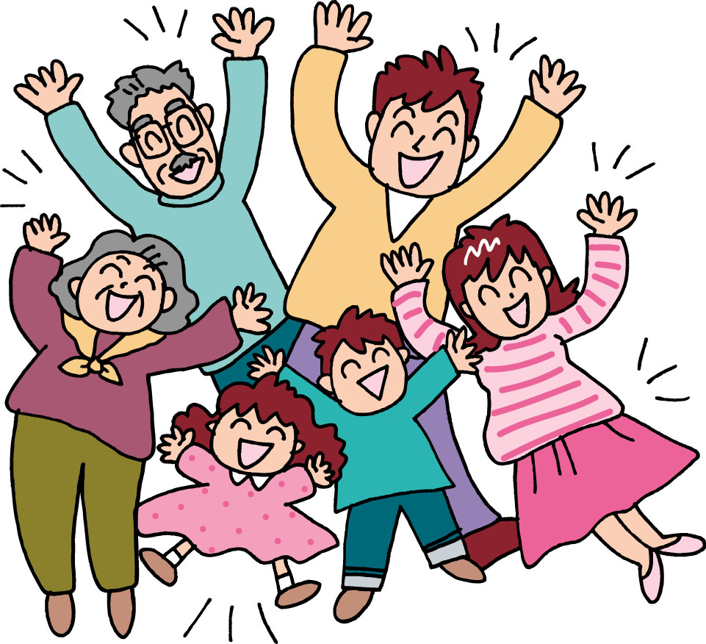
Your local Neighborhood/Town
Association is
JICHIKAI
Thank you for your cooperation!

Contact Information
Name：
Address：
Phone：
JICHIKAI ACTIVITIES

Aiming to make community a comfortable place to live, each JICHIKAI conducts activities such as those listed below;
Disaster Prevention & Recovery
Each JICHIKAI organizes its own self-prevention program for mutual help in case of disaster, conducts disaster drills, and keeps fire extinguishers and other emergency equipment in its area.
Managing Waste Collection Points and Environment Beautification
Each JICHIKAI maintains waste collection points, and cleans up streets, parks, and other public places in its area.

Relaying local Information from Tsu City, Mie Prefecture, etc. quickly
Each JICHIKAI distributes information from local authorities through PR Magazines, passing out Kairanban (circular notices) among members, and updates bulletin boards.
Lighting Streets for Crime Prevention
Each JICHIKAI establishes Crime Prevention Lights and maintains them with its own funds to improve street lighting. Thanks to them, you can use the streets at night securely.

Events to Promote Friendship in the Community
Each JICHIKAI holds social gatherings such as sports activities, local festivals, trips, etc. in order to deepen the friendly relationships among members.

Activities for Traffic Safety and Crime Prevention
Each JICHIKAI patrols its area and relays information to residents in order to prevent tragic traffic accidents and crimes, and makes efforts to make the neighborhood.

Cooperation with other related entities
Each JICHIKAI cooperates with other entities
such as Kodomokai (Children’s association),
and the Roujinnkai (Elderly People’s
association) to promote local public activities.

Social Welfare Activities
Each JICHIKAI promotes local social welfare activities in association with the Social Welfare Council and other public organizations to improve society.

JICHIKAI ADMINISTRATION OF TSU CITY

Tsu City Jichikai Federation ｜
10 Branches of Federation ｜
Regional Jichikai Association ｜
Jichikai (Single Neighborhood) ｜
Members (Individual)
・・・・・All of Tsu City

・・・・・10 administrated sub-areas of Tsu City

・・・・・Divided by school areas
(An area usually aligned with the local elementary school)
・・・・・Approx. 1,000 Jichikai groups in all of Tsu City

