For guardians of children who will enter a Japanese elementary school in April 2026
【英語】

就学前日本語教室「つむぎ」のご案内
School Readiness Program: TSUMUGI INFORMATION

Join the TSUMUGI Japanese class and experience
a taste of Japanese elementary school life!

１ Venue: (1) Tsu Municipal Keiwa Kindergarten
(2) Tsu Municipal Takadyaya Elementary School
*Please choose the venue closer to your home ((1) or (2)).
*If applications exceed capacity, we may ask you to switch venues.
*The program content is the same at both venues.

２ Dates: Year 2026 January 17(Sat), 24(Sat), 31 (Sat)
February 7(Sat), 14(Sat), 21(Sat), 28 (Sat)
March 7 (Sat)

Time: (1) Keiwa Kindergarten: 10:00-11:30 (Reception from 9:40)
(2) Takadyaya Elementary School 13:30-15:00 (Reception from 13:10)

３ Content:【For children】 -Experience activities from everyday elementary school life
-Learn to read hiragana Japanese letters
-Practice writing their name in hiragana
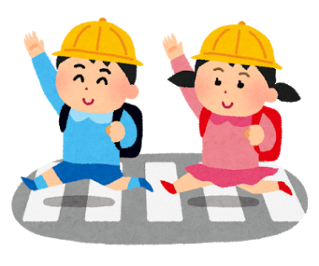
-Build basic elementary school vocabulary
【For guardians】-School enrollment guidance/ orientation
-Educational counseling
*Interpreters are available.

４ Participant Notes: -One guardian must accompany each child.
-Please don’t be absent without notice.

５ Fees: Free of charge

６ How to apply: Please submit the application form to your child’s kindergarten or nursery school by Friday, November 21st.

【Contact】 Tsu-shi Kyouiku Iinkai Jimukyoku , Jinken Kyouikuka
(Tsu City Board of Education Office, Human Rights Education Division)
TEL: 059-229-3249

Maps & QR Codes for Directions
- 津市立敬和幼稚園 〒514-0018 市中河原445
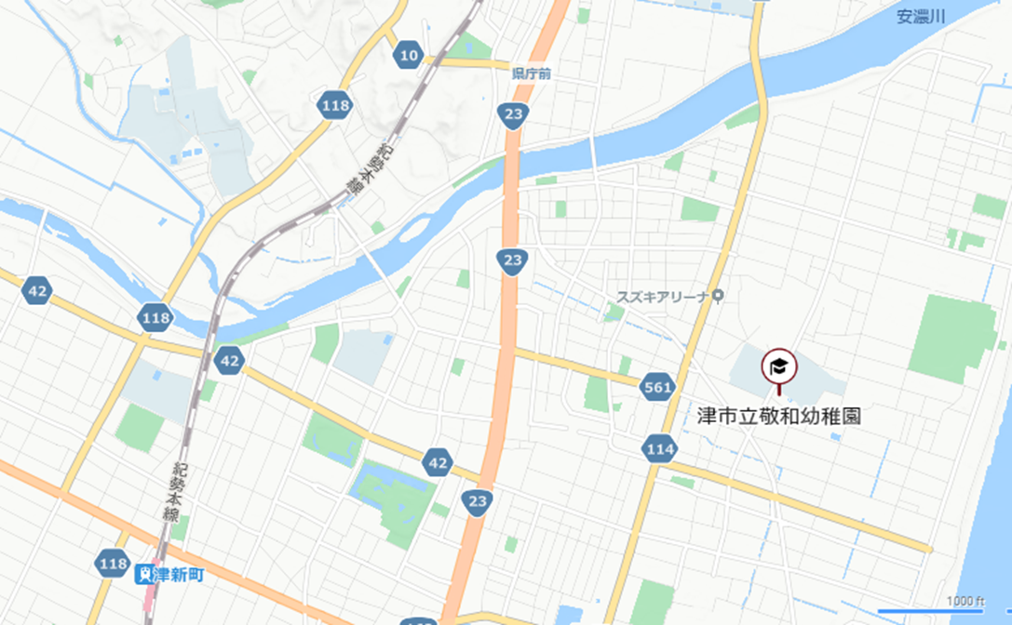
Tsu Municipal Keiwa Kindergarten (445 Nakagawara, Tsu)
Tsushimmachi Station
Keiwa Kindergarten


- 津市立高茶屋小学校 〒514-0819 市高茶屋３目1-1
Tsu Municipal Takadyaya Elementary School
(3Chome-1-1 Takajaya, Tsu)
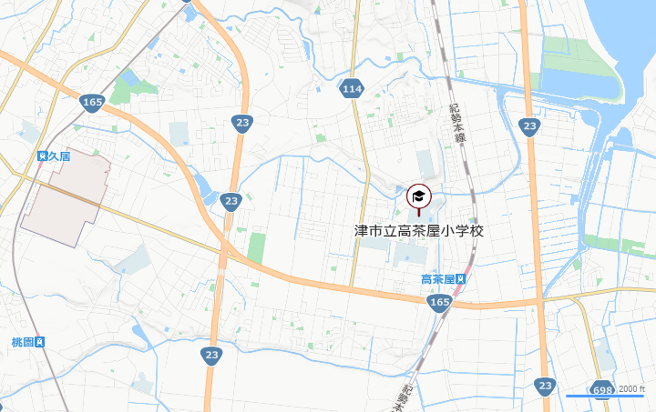
Takachaya Station
Takadyaya Elementary School

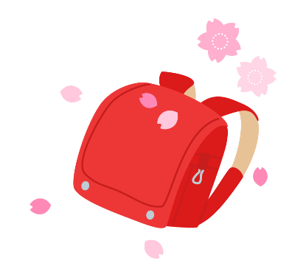
【英語】
School Readiness Program: TSUMUGI
Japanese Class Application Form

Child’s name
Parent/Guardian’s name
Address
Telephone
Language
Interpreter needed for parent/guardian  (circle one) | ( ) Yes ( language: )  ( ) No
Current kindergarten (yochien)/ or nursery school (hoikuen/kodomoen) | ( ) Yochien  ( ) Hoikuen  ( ) Kodomoen  ( ) Not enrolled in any kindergarten/ nursery school
Preferred venue  (circle one) | ( ) Keiwa Yochien  ( )Takadyaya Elementary School  *Choose and circle the venue your prefer.  *If applications exceed capacity, we may ask you to switch venues.  *The program content is the same at both venues.
Media consent  (circle one) | May the Board of Education use photos/videos of your child taken during the TSUMUGI class on our official channels (e.g., website, Facebook)?  ( ) Yes / ( ) No
I would like to apply for TSUMUGI class.

*Please hand this form to your child’s kindergarten or nursery school. You may also bring or mail it to Tsu City Board of Education Office, Human Rights Education Division.
[Mailing Address] 〒514-0035 Tsu-shi Nishi Marunouchi, 37-8
Tsu-shi Kyouiku Iinkai Jimukyoku, Jinken Kyouikuka
(Tsu City Board of Education Office, Human Rights Education Division)
[TEL] 059-229-3249
Submission deadline: Friday, November 21

